Machine Learning

* **Difference between AI vs ML vs DL**

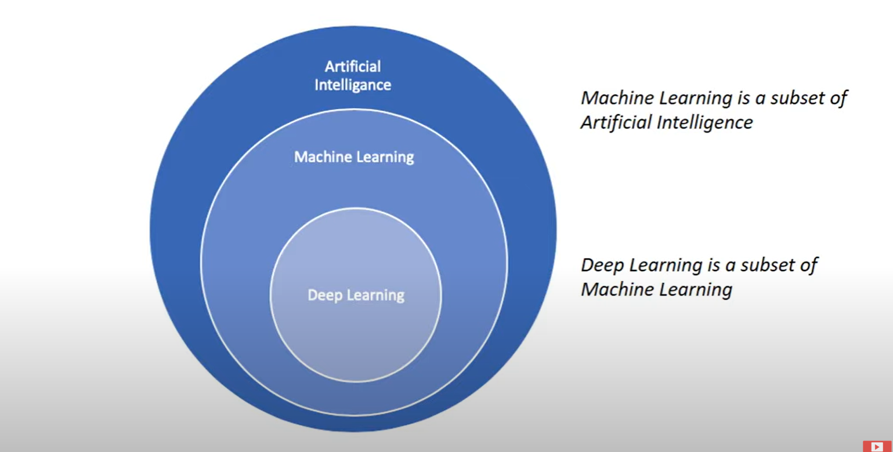

* **Artificial Intelligence:** It is a branch of computer science that is concerned with building smart and intelligent machines.
* **Machine Learning:** It is technique to implement AI that can learn from the data by themselves without being explicitly programmed.
* **Deep Learning:** It is subfield of ML that uses Artificial Neural Networks to learn from the data.

Boom for Deep Learning is *alpha go* game bot created by **Deep Mind** company which defeated world champion by 4-1

* **Types of Machine Learning**
* Supervised learning – ML algorithm learns from labelled Data
* Unsupervised learning – ML algorithm learns from unlabeled data
* Reinforcement learning – Reinforcement learning is an area of ML with how intelligent agents take actions in an environment to maximize it rewards

Ex. Chess Bot

* **Types of supervised learning**
* Classification – Predicts the class or discrete values eg. Male or Female

**Algorithms** – Decision Tree Classification, Random Forest Classification, K-nearest Neighbor

* Regression – This predicts the quantity or continuous value eg. Salary of employee

**Algorithms** – Logistic Regression, Polynomial Regression, Support vector machine

* **Types of unsupervised learning**
* Clustering – This involves grouping the similar data points

Ex. One can use to create group of apple and mango images without label

* Association – This is used to find important relationship between data points

Ex. Buyer 1 – Bread, Milk, Egg, Fruits; Buyer 2 – Bread, Milk, Jam, Vegies

What we find in most cases buyer buys bread and milk together so in this case if someone buys bread, we can suggest them milk

* **Algorithms:**

K-means clustering

Hierarchical clustering

Principal Component Analysis (PCA)

Apriori

Eclat